**H1: Wattco’s Guide to Industrial Heaters for the Chemical Industry**

In the 21st century we have the ability to control heat to thank for much of the technology which improves our lives. Virtually every industry uses heat in some capacity during the manufacturing process, but this article will focus on how heating is applied in the chemical [manufacturing industry](https://www.britannica.com/topic/chemical-industry).

**H2: Introduction to Industrial Heating Industry**

Many industries such as manufacturing and chemical processing require substances to be a precise temperatures to manufacture products. Often times, industrial heaters are used for their efficacy and dependability.

This article will give a concise overview of industrial heaters and how they fit into various chemical industries. It is our hope that this article will help you better understand the role our products play in manufacturing, answer some questions you may have about heaters or your needs, and finally, serve as a resource for anyone seeking to educate themselves about the industry.

**H2: How Does An Immersion Heater Heat Chemicals?**

The basic functioning of an immersion heater isn’t too dissimilar from the hot water heater you have in your home, though industrial heaters operate at a much higher capacity than residential systems.

**H2 - Introduction to chemical industry**

The chemical industry includes any company which [produces chemicals at industrial scale](http://www.essentialchemicalindustry.org/the-chemical-industry/the-chemical-industry.html). Since the industrial revolution the chemical industry has truly taken off. Before the industrial revolution specialized chemicals were being made and used, but on a far smaller scale.

Sulfuric Acid was one of the [first chemicals to be manufactured](https://en.wikipedia.org/wiki/Chemical_industry) en masse by Joshua Ward in 1736. By 1749 one of the first large chemical factories was established in Prestonpans, Scotland, and the scale of production only increased since then.

By the late 19th century the process of chemical manufacture had become more refined and sophisticated, allowing industrialists to produce larger quantities and varieties of chemicals. Although the chemical industry hand its beginning in the UK, the next generation of industrial chemical industry and its largest companies were largely consolidated in Germany, France, and the United States. Today’s chemical producers are global corporations with production facilities in various countries.

Industrial chemical manufacture makes modern life and all of the products we take for granted possible. From producing medicine to consumer products, we have the chemical industry to thank for many things we take for granted.

**H2 - Reasons why you need an industrial heater in chemical industry.**

The chemical industry has changed a great deal over the last hundred years, and chemical manufacturers are constantly looking for new ways to optimize the manufacturing process. Heating and temperature play a big role in this on-going and Wattco works closely with clients to find solutions and optimizations for the chemical manufacturing process.

Back in the early 18th century, the inability to control heat effectively produced bottlenecks in the manufacturing process. Scientists and businessmen were always vigilant to innovate and temperature control was a large factor in optimization.

**H2 - How does industrial heater compare to other types of heaters/heating methods?**

Industrial immersion heaters like the ones Wattco offers are bar none the most effective and efficient means of managing [temperature control in the chemical manufacturing process](http://www.wattco.com/Types-of-Process-Heating-Systems.html). The chemical production process often requires reactions to take place in specialized vessels at elevated pressures and temperature. Depending on the product desired, one of a variety of techniques including distillation, precipitation, crystallization, adsorption, filtration, sublimation, or drying are used. Each of these forms of reaction require different temperature and pressure conditions to work and Wattco is here to ensure the desired product is reached as efficiently as possible.

**H2: What are The Different Types of Industrial Heaters Used In The Chemical Industry?**

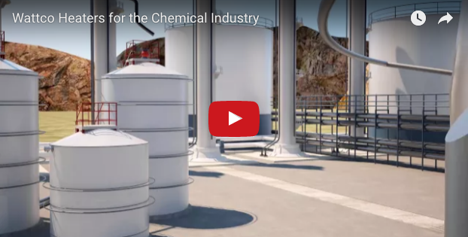

Watch our video topic about Wattco Industrial Heaters in the Chemical Industry for a brief overview of the different types of heaters and their applications. Then read on for a comprehensive explanation of each type of heater and application.

**H2: What are the different heaters you can chose for heating chemicals? Compare. [image of each type of heater in each section]**

Wattco offers a variety of heaters for a range of applications in the chemical processing industry. Finding a heater to meet your needs is a question of having a clear understanding of what function the heater needs to fulfill. Read through the overviews of our immersion heaters below to find the type which is fit for your purpose.

**H3 - Inline Heaters.**

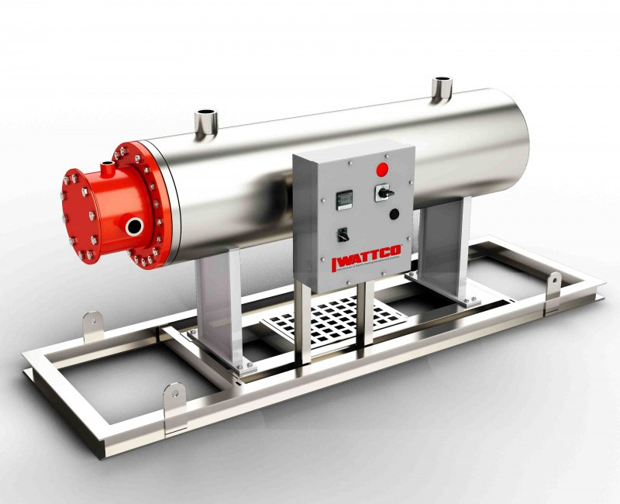

Unlike a heat exchanger, which strips heat from another source to heat up the liquid, an inline heater converts electrical energy into heat which is then injected into the liquid in questions. The inline heater is known primarily for its efficient heat transfer, the ease with which it can be installed into vessels, ease of maintenance, and its high compatibility with standard industry piping infrastructure.

Common instances where Circulation heaters are used include waste oil removal and steam and water processing. These later processes often require circulation heaters to regulate the temperature of the fluid being transferred so that its viscosity is high enough to travel freely through the pipe.

Controlling the liquid’s flow rate is accomplished by manipulating the wattage to obtain the desired temperature. Controlling the system is usually done with a control panel which is typically matched to the circulation heater depending on wattage.

The inline heater is made up of an immersion heater coated by an anti-corrosion metallic vessel chamber to keep the heater from being corroded or otherwise damaged by the potential harmful chemicals it will be immersed in. The casing helps insulate the system and prevent heat escaping from the circulation system, further improving efficiency.

Precise control of the heating system’s temperature can be achieved with tools like RTDs and digital thermocouples. Some manufacturers choose to invest in extra protection and elect to add optional components including moisture resistant or explosion-proof housing.

Another optional feature is drain valves which expedite system maintenance, making it easier to remove leftover fluid or residue. Depending on the heater’s application special mounting can be requested for both mobile and stationary applications. Further customization of the heater can be arranged depending on the process requirements, including orientation and type of flange.

The range of inline heaters available on the market is as numerous as the range of situation which demand in line heating. Finding the right heater for a given process is often a matter of getting a heater custom tailored to meet specific needs.

Since inline heaters often heat a liquid which is corrosive or otherwise damaging to the element, it is most often protected by a sheath. The typical design of this type of heater is a group of heating elements mounted inside a rounded tube. Thermal insulation is often inserted in order to increase the efficiency of the heating process, especially if a flowing medium requires heating.

Nearly every inline heater uses thermocouple sensors which are incorporated into a control system for managing temperature range.

Within the industrial chemical industry the most popular applications of inline heaters are heating oil, corrosive chemical solutions, water-cooled engines, among others.

**H3 Wattco Inline Heater Specifications**

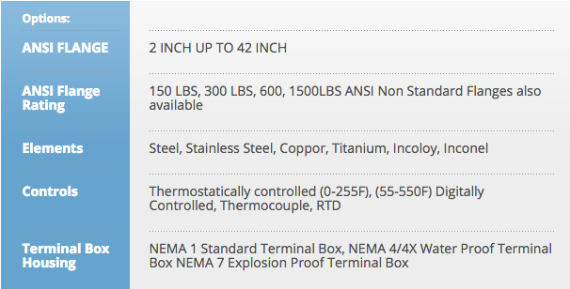

**H3** **- Screw plug heaters**

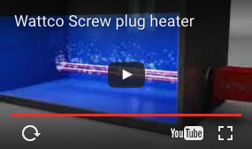

Common applications of Screw Plug heaters include heating gases and liquids in various tanks and vessels that require precise control. Digital control panels and mechanical thermostats are well paired with screw plug immersion heaters, helping them reach the target temperature with accuracy and efficiency. This operational efficiency helps expedite the manufacturing process without sacrificing quality. Thermowells are often installed alongside screw plug heaters as high limit temperature probes to protect the fluid and not disrupt the process.

Screw plug industrial heaters are prized for the speed with which they can heat gases and liquids. Wattco screw plug heaters are specially designed for heating to occur at a rapid rate, translating to fast heating of liquids or gasses. These qualities make Wattco heaters especially practical in applications where there is a need for rapid change in temperature of a solution.

Popular screw plug heater industrial applications include the food and beverage industry, and laboratory clinic industry. Applications which include the use of hydraulics, lubricants, or the heating of flammable fluids which are housed in explosion-proof containers are among the most popular uses of screw plug heaters.

**H3** **- Wattco Screw Plug Heater Specifications**

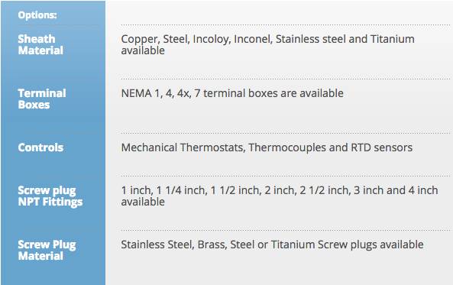

**H3** **- Over-the-side heaters**

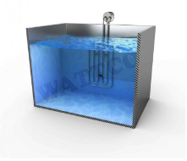

An over the side industrial chemical heater is typically inserted into the top of a tank or vessel then installed with brackets to keep it secure. Care must be taken to calculate where the cold sections are and to ensure that the desired temperature is maintained even if the level of liquid in the container lowers from evaporation, drainage, or some other reason. A heater commonly used in the petroleum and chemical manufacturing industries, an over the side heater is built to withstand harsh conditions indoors or outdoors. In terms of value, the over the top heater is Wattco’s most popular type of industrial heater.

One of the great qualities of an over the side heater and what makes it so popular is that it leaves plenty of space in the tank for other fluid processing operations to take place. Because the over the side is right up against a wall it does not disrupt other processes. Furthermore, it can quickly be taken out once the solution has reached the desired temperature. The construction of the heating element is designed to ensure longevity at top performance. Elements can be made from steel, copper, cast alloy, and even titanium, as needed. For use with especially hazardous chemicals Wattco recommends a fluoropolymer or quartz coating for the element.

**H3** - **Wattco Over-the-side Heater Specifications**

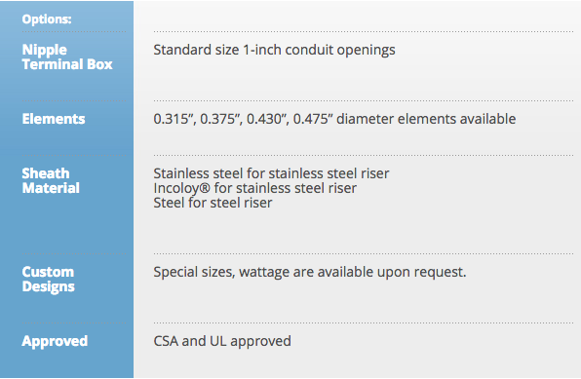

**H3: Wattco Pipe Heaters**

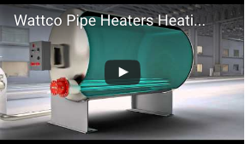

Unlike other industrial chemical heaters offered by Wattco, a pipe heater never comes in direct contact with the substance being heated. Instead, indirect heat reaches the liquid, passing through the pipe from the heating element. Such an arrangement makes for exceptionally easy maintenance. The contents of the tank don’t even need to be removed to conduct a thorough cleaning or to replace the heating element. The pipe heater features listed above make it an excellent candidate for various applications including the food industry and petroleum industry.

**H3 - Pipe Heater Specification**

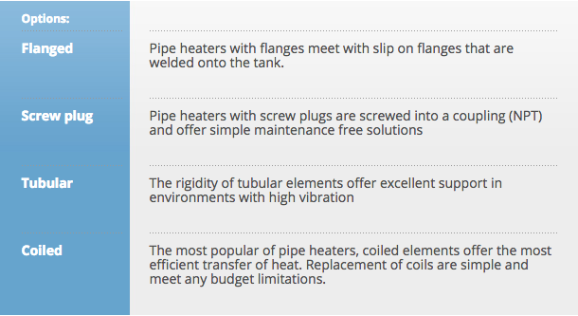

**H2 - What are common applications of heaters for chemicals?**

Different industrial chemical heaters are required depending on the specific application, the storage vessel, and the manufacturing process. Below we’ve summarized some of the common industrial chemical manufacture requirements and provided a short overview of the appropriate heater.

**H3 - Glycol Reboiler**

Glycol reboilers are a means of glycol dehydration, or a liquid desiccant system used to extract water from natural gas and natural gas liquids. Glycol Reboilers are the most common means of extracting water from natural gas due to their efficiency. Water is removed from the natural gas in order to avoid complications further in the refinement process.

The recommended heaters for a glycol reboiler system are [circulation heaters](http://www.wattco.com/circulation-heaters.html) or [inline heaters](http://www.wattco.com/inline-heaters.html). Read through our [case study examining the role of industrial heaters in the natural gas industry](http://www.wattco.com/casestudy/gas-and-steam-heating.html), specifically regarding gas and steam heating.

**H3 - Freeze Protection**

Sometimes chemicals need to be brought down to extremely low temperatures in industrial chemical manufacture, and in these cases the pipe or vessel holding the liquid needs to keep warm enough that the flow of the liquid within is not interrupted and it does not freeze.

For such cases Wattco recommends either a flanged heater or an over the side heater. Read through our [flanged heater case study](http://www.wattco.com/casestudy/preventing-liquid-from-freezing.html) or our [over the side heater case study](http://www.wattco.com/casestudy/Heat-trace-cable-vs-immersion-heaters.html) for more in-depth information on these applications.

**H3 - Tank Heating**

Tank heating is exceedingly common in the chemical industry, and Wattco Flanged heaters are the most suitable products for the job. Learn more about flanged heaters in application by reading through our [case study about flanged heating and tank heaters](http://www.wattco.com/casestudy/tankheating.html) or about how a power plant uses an [immersion tank heater for for tank heating](http://www.wattco.com/casestudy/tank_heating.html).

**H2 -** **How can you tell which heater you need?**

If you’d like to learn more about Wattco heaters and which one is right for your application visit our [industrial heater case studies](http://www.wattco.com/casestudy/) page to find the information you need to make an informed purchasing decision. The option of calling one of our representatives to find out which piece of Wattco equipment best fits your purpose.

Wattco personnel are also available for [live assistance](https://hostedusa1.whoson.com/chat/chatstart.htm?domain=www.wattco.com&timestamp=1475067323164&session=9-1472735359386) and when you request a quote you’ll receive it within 24 hours.